**How to use Microsoft Power BI**

**(Basics)**

The view of power BI dashboard after successfully installs the Power BI

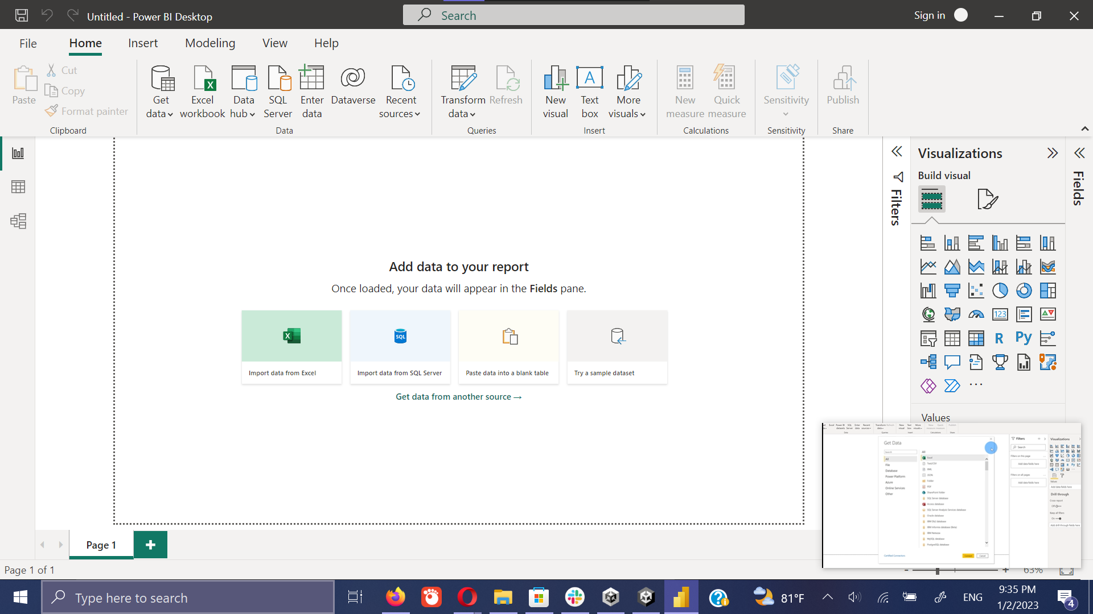

Load data

1. First click on the **Get data** in menu bar.
2. Then select the file type which required to upload. (Here it uses the Excel sheet.
3. Then select the required Excel file using the file picker.

Link for the data set.

<https://ugvle.ucsc.cmb.ac.lk/pluginfile.php/17968/mod_assign/intro/Kevin%20Cookie%20Company%20Financials.xlsx>

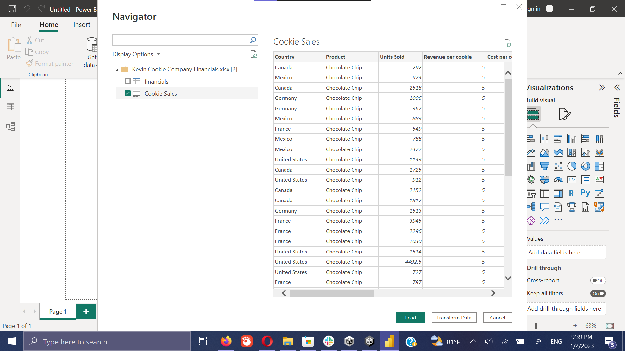

Transform Data

1. Here we can transform (clear/preprocessing) the data as we required before it loaded to the Power BI dashboard by clicking on the **Transform Data**. If we are sure all set to work, we can directly click on the **Load** button to load data set to the dashboard.
2. The data transform happens in the **Power BI Query Editor**. It will automatically open when it clicks on the **Transform Data.**

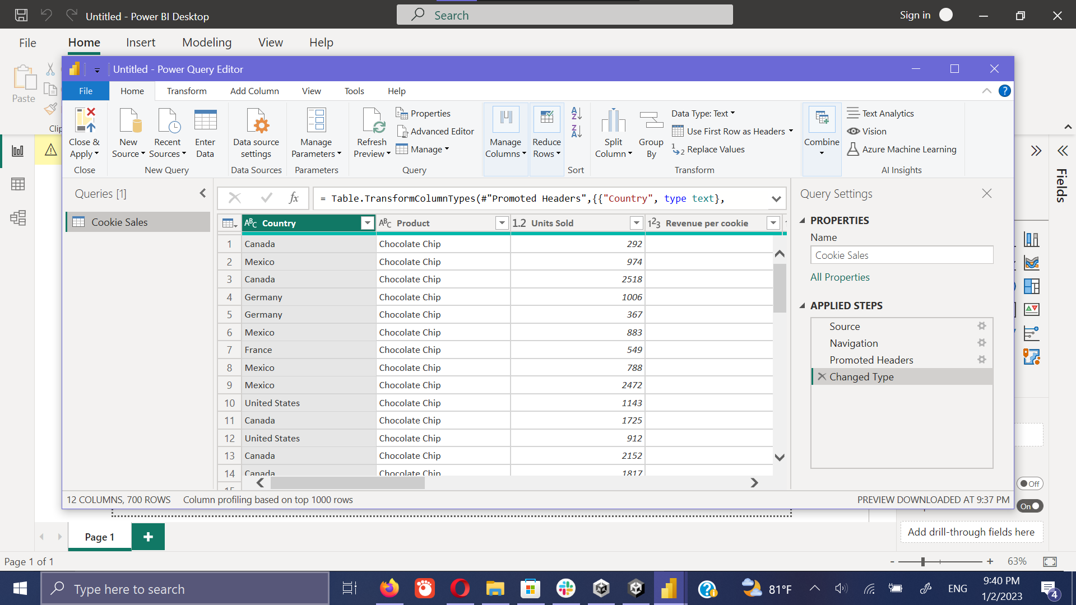

* 1. Remove unwanted data

It can easily do by clicking on the **Header Name** and deselecting the data what does not want o analysis.

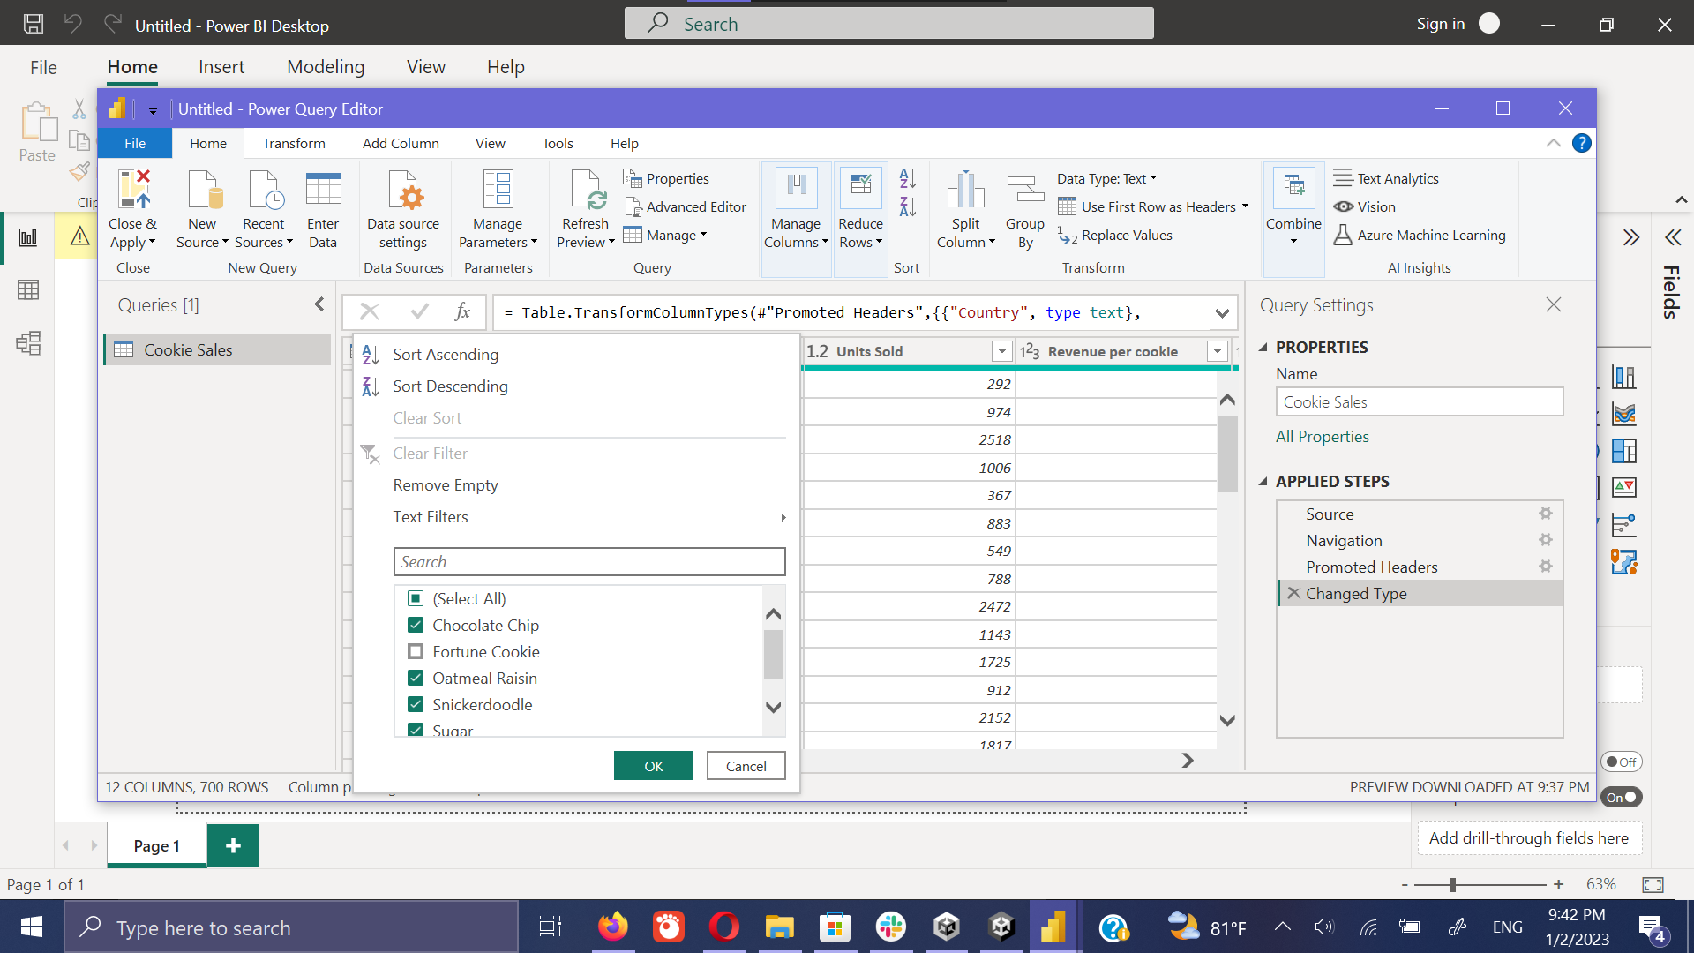

* 1. Convert to whole numbers

In incident where it wants to convert the decimal numbers to the whole numbers. It can easily accomplish by right clicking the Header of required column and selecting the **Change type - > Whole Numbers.**

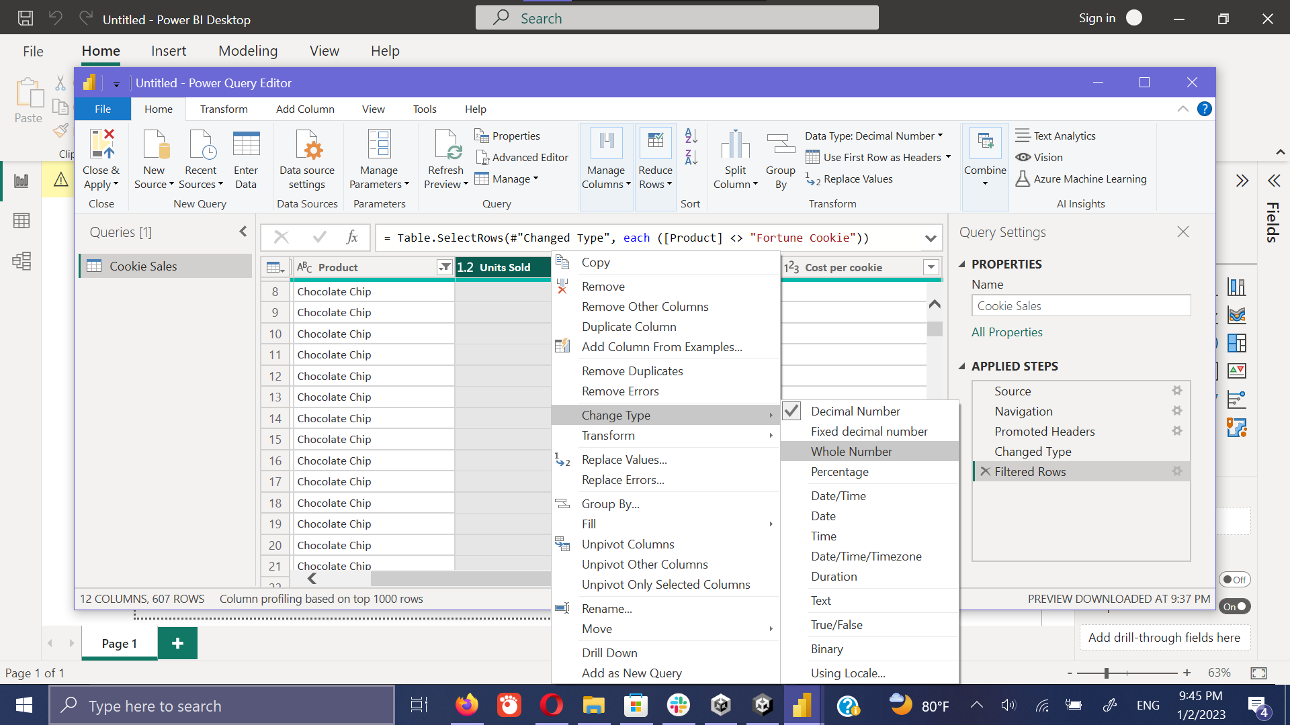

* 1. Change the Header name

This can be easily done by clicking on the header name. Simply like rename a folder in desktop environment.

* 1. Undo the performed Transformation

It it’s required to undo the perform transformation action, it can easily be done by moving the **Applied Steps** panel in the window. By clicking the performed action, it displays the action that we had done in step wise. We can remove it simply clicking on the removing button.

Click on **Filter Rows**

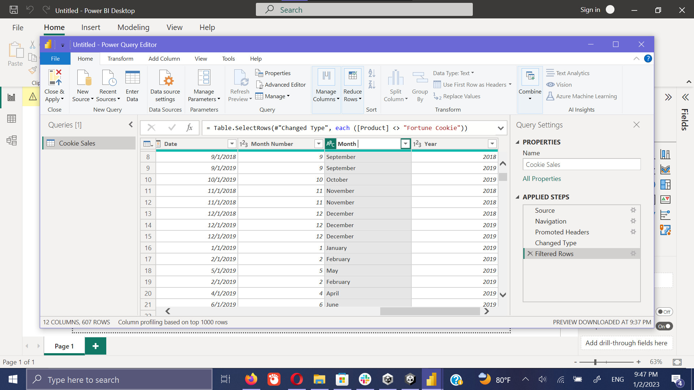

Pop window showing the summery of action performed.

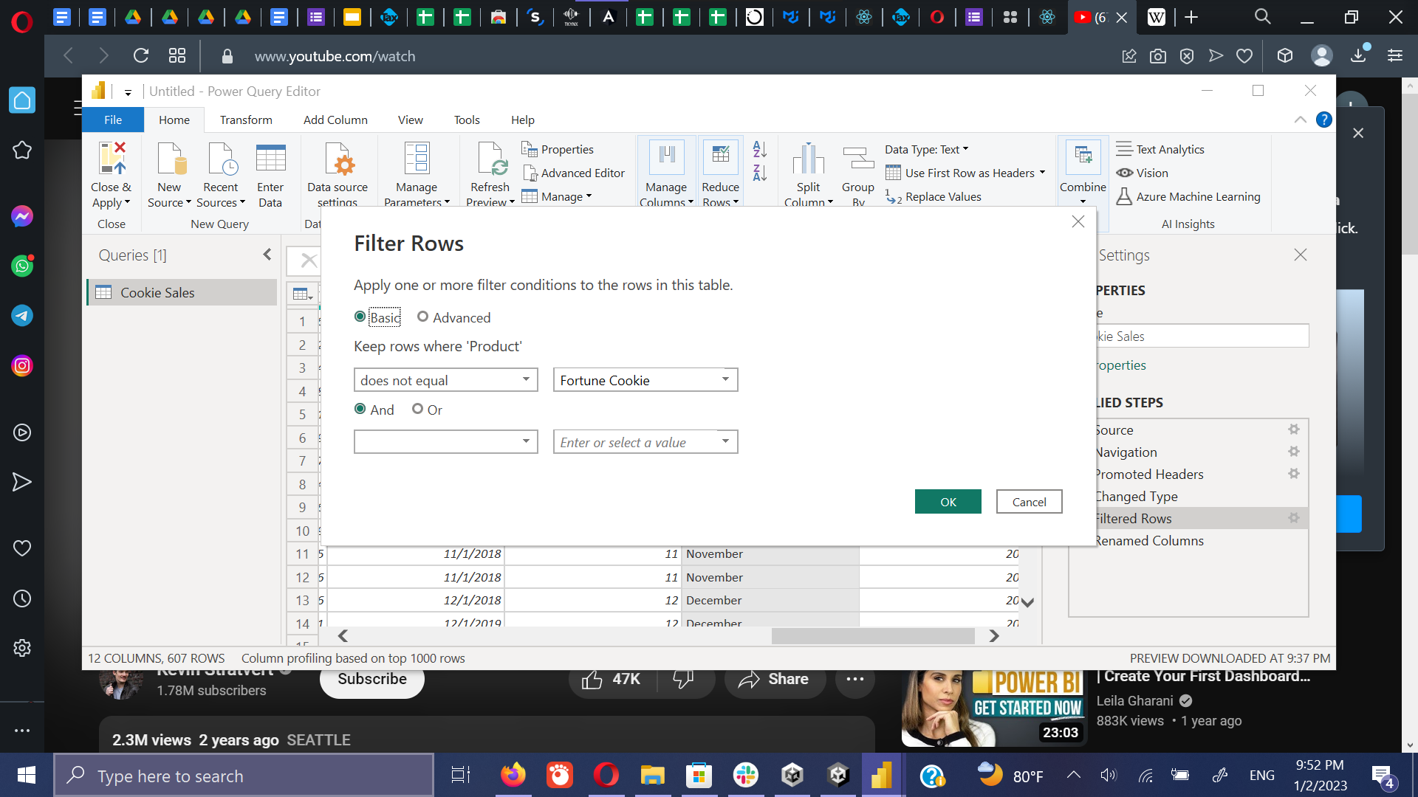

Click on the remove button

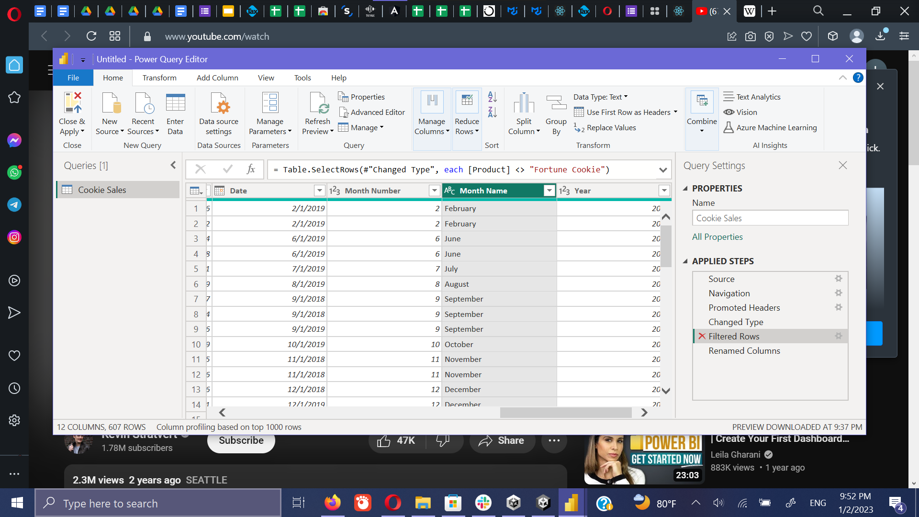

* 1. Import new data set from web

First click on the **New Source** and select the **Web.** Then it loaded the pop window to load the data set from the from the web. After providing the link, Click on the **ok** button.

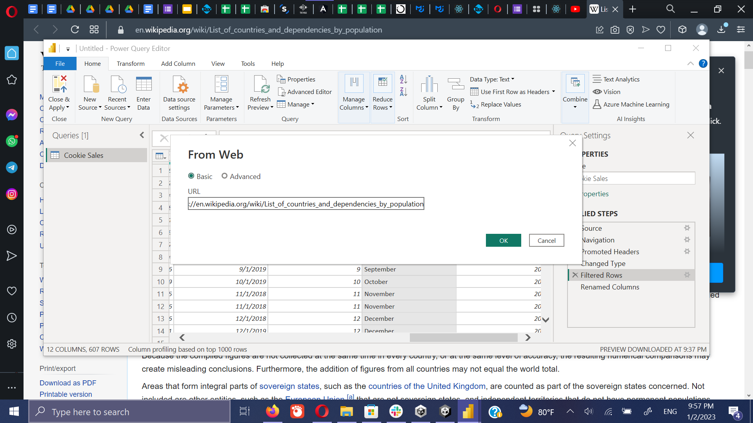

Then it loaded the data set. This is very attractive feature in Power BI, where it can load the data sets in the websites.

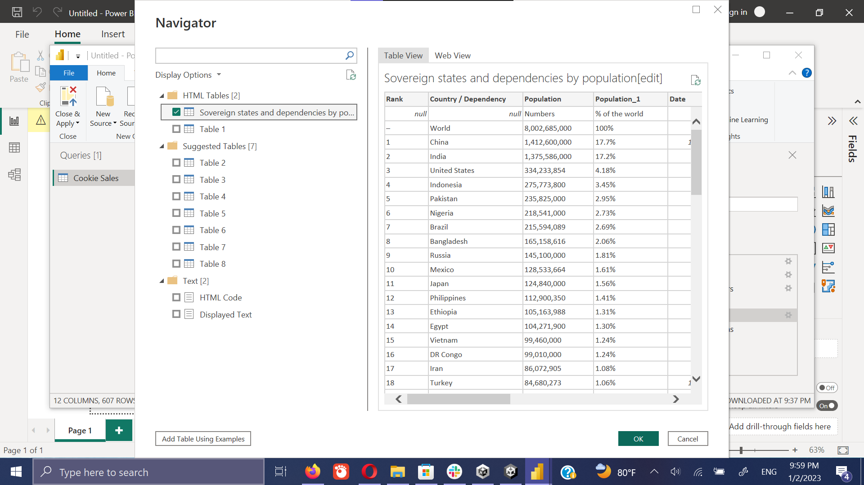

After selectin the required data set from the website the simply click on **Ok** button and load the data into the Query Editor.

Here for the demonstration, we loaded the population amount of the country from the Wikipedia.

<https://en.wikipedia.org/wiki/List_of_countries_and_dependencies_by_population>

Here loaded data set consists with several unwanted the data. We can remove them by selecting them separately. TO remove a column, only needs to right click on the heading of the column.

Then select the remove option.

Remove Rank column

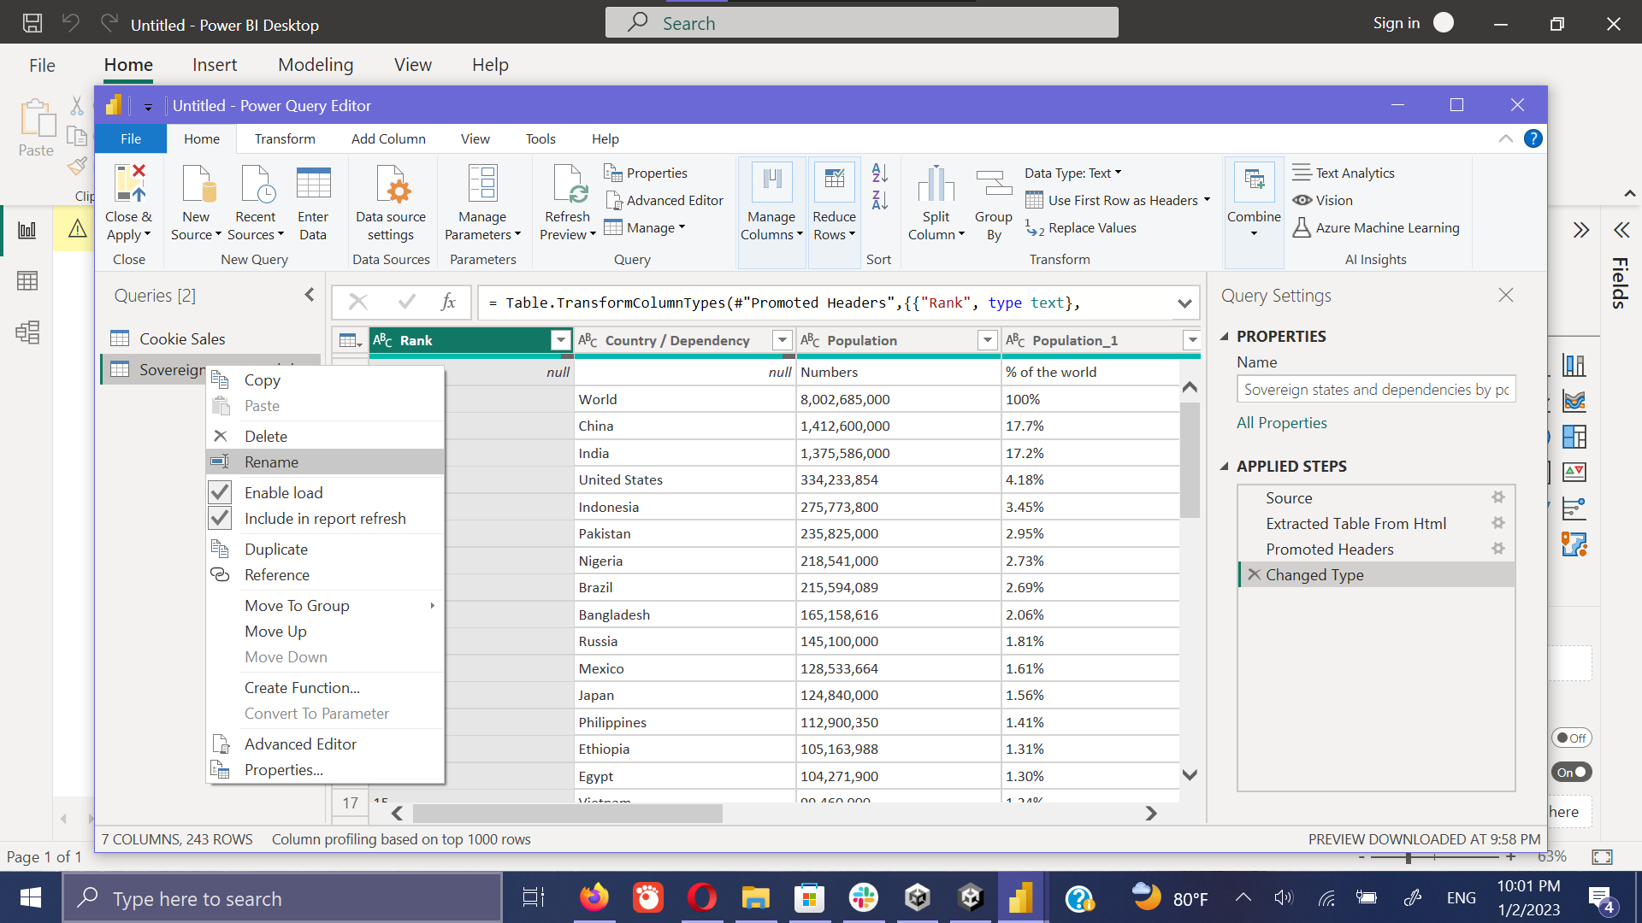

Remove the population by percentage column

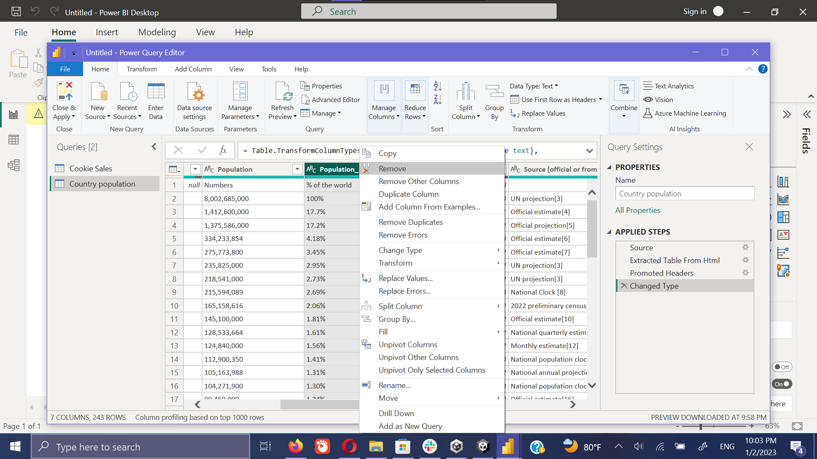

Remove Data column

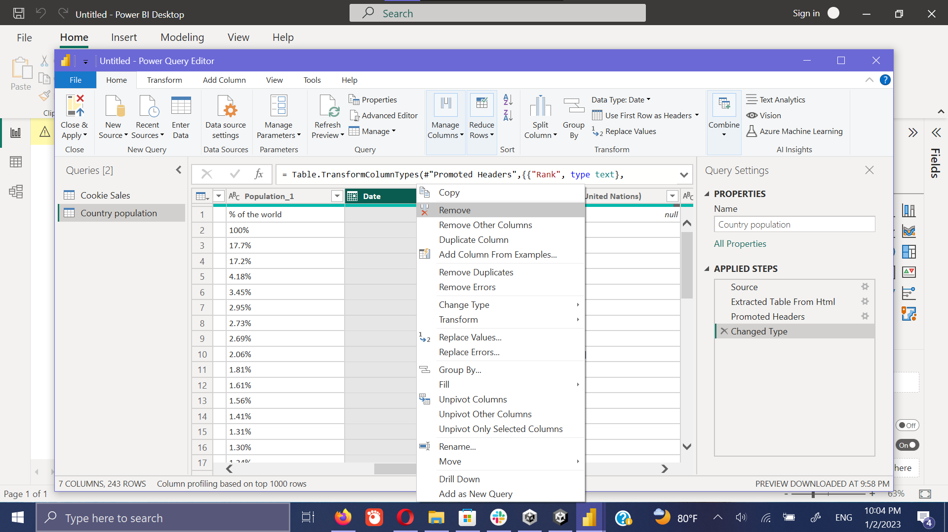

Remove source column

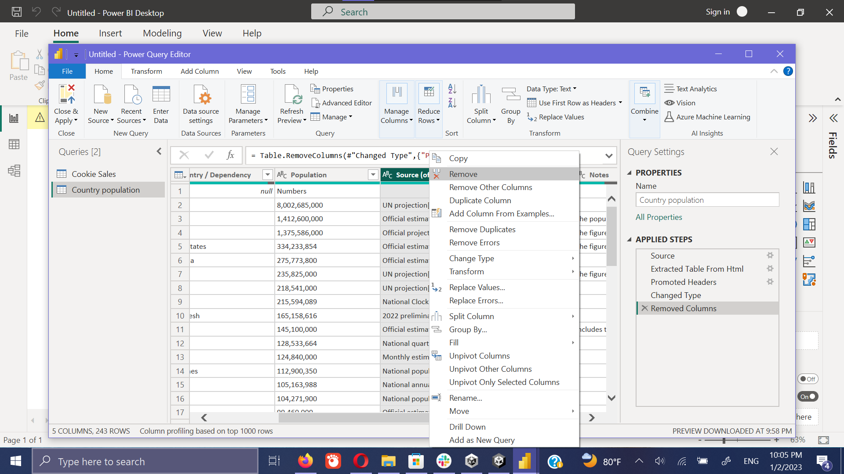

Likewise, it can remove all the other unwanted columns by keeping the **Country** and the **Population** column.

The final cleaned table view is like bellows.

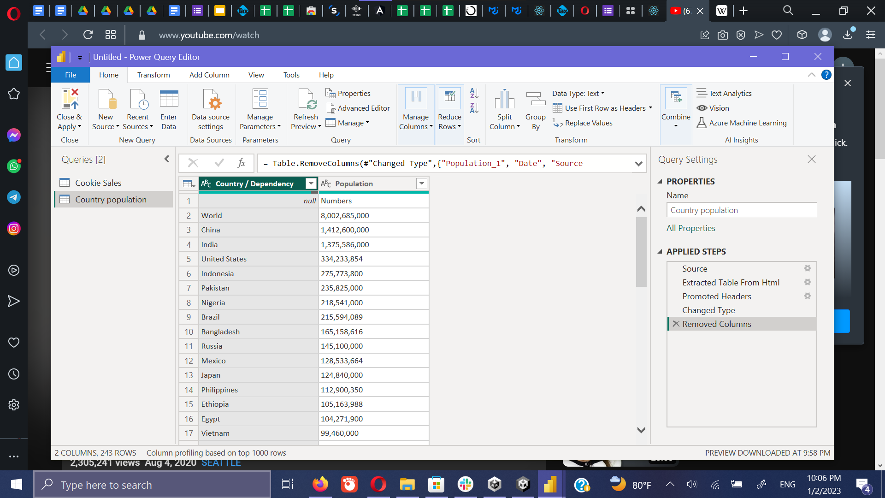

Now it’s required to select the countries that we required to analyze out of all countries which is loaded from the Wikipedia.

This can be simply accomplished by clicking the filter option on the heading in each column and selecting or deselecting the countries that we required. For the example we are going to select 5 countries.

The reason to filter the up only up to the 5 countries is, we have only **German, France, United States, Mexico, Canada** as the countries in our Kevin Cookie Company Financials data set. Out target is to attach a population column to the Kevin Cookie Company Financials data set which is downloaded from the Wikipedia.

Filleter and select the countries.

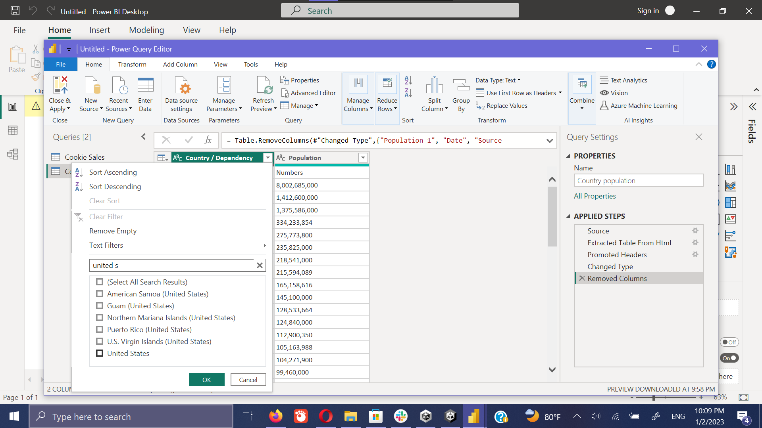

Final selected country list with the population.

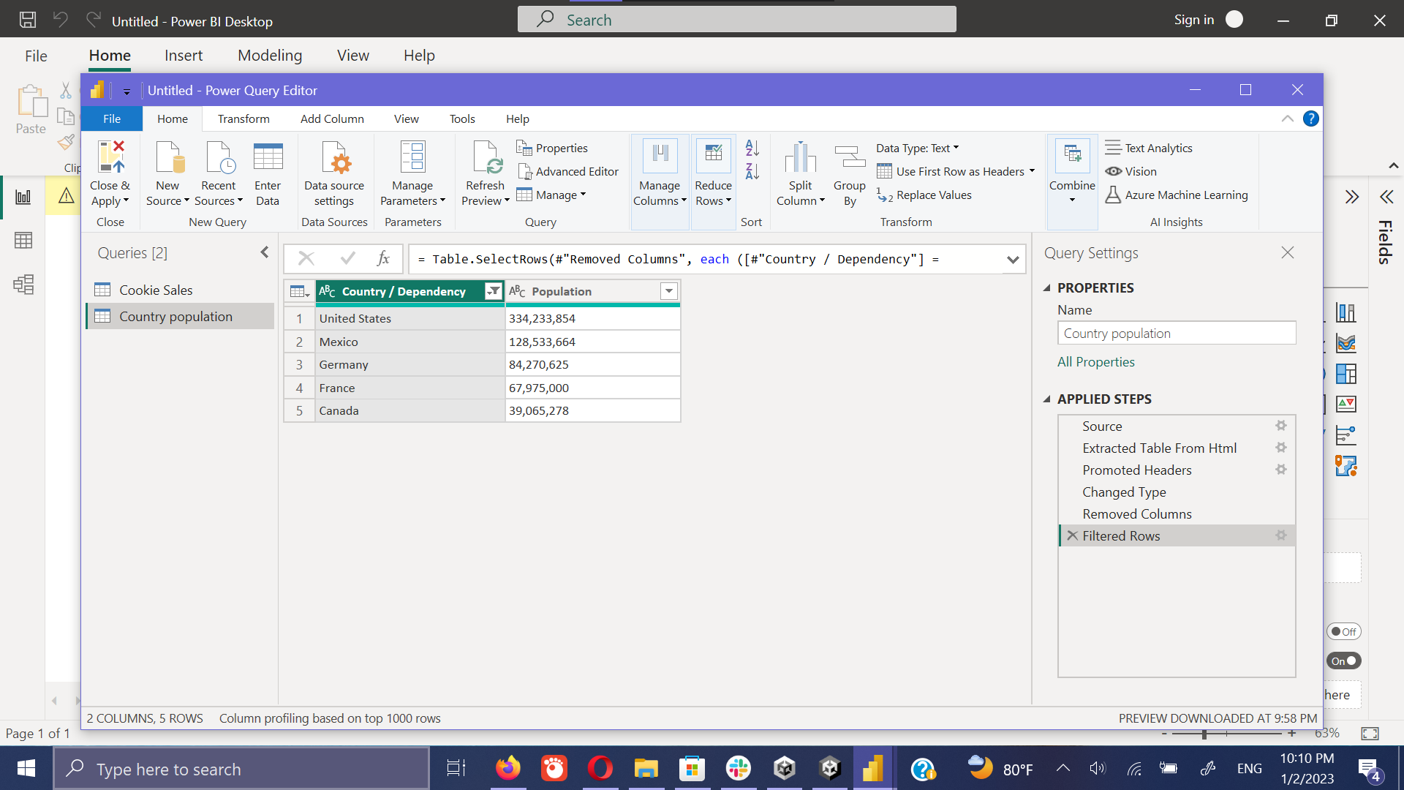

* 1. Connect tow data sets.

Merge the 2 data sets (Connect the country & population table to the Kevin Cookie Company Financials data set)

First click on the **Combine** tab and then on the **Merge Queries.** It brings the below window.

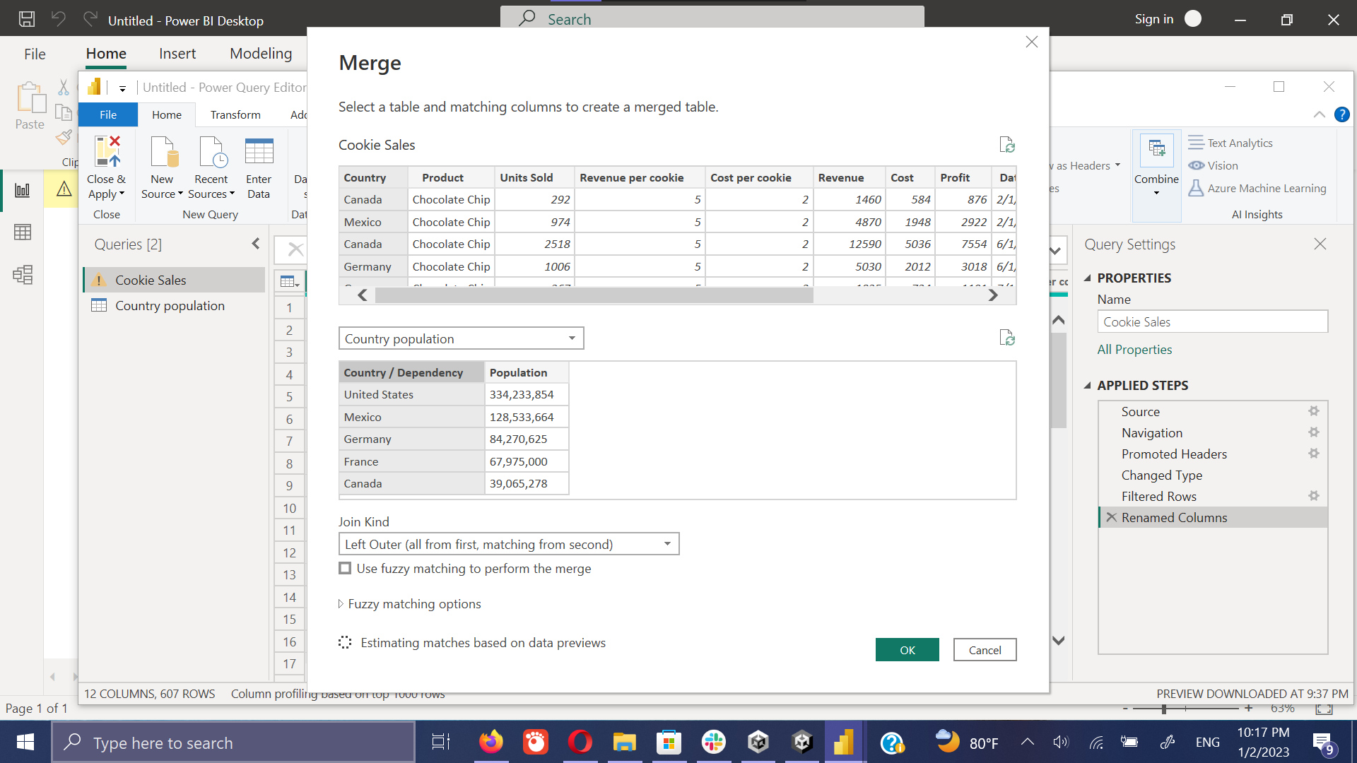

Then it needs to select the requires column from each table. Here we select the **Country** from the Kevin Cookie Company Financials tables and **country** from the Kevin Cookie Company Financials table.

After selecting the required columns, it needs to click on the **ok** button.

Then will bring the below privacy window. Simply click on the **ignore** checkbox.

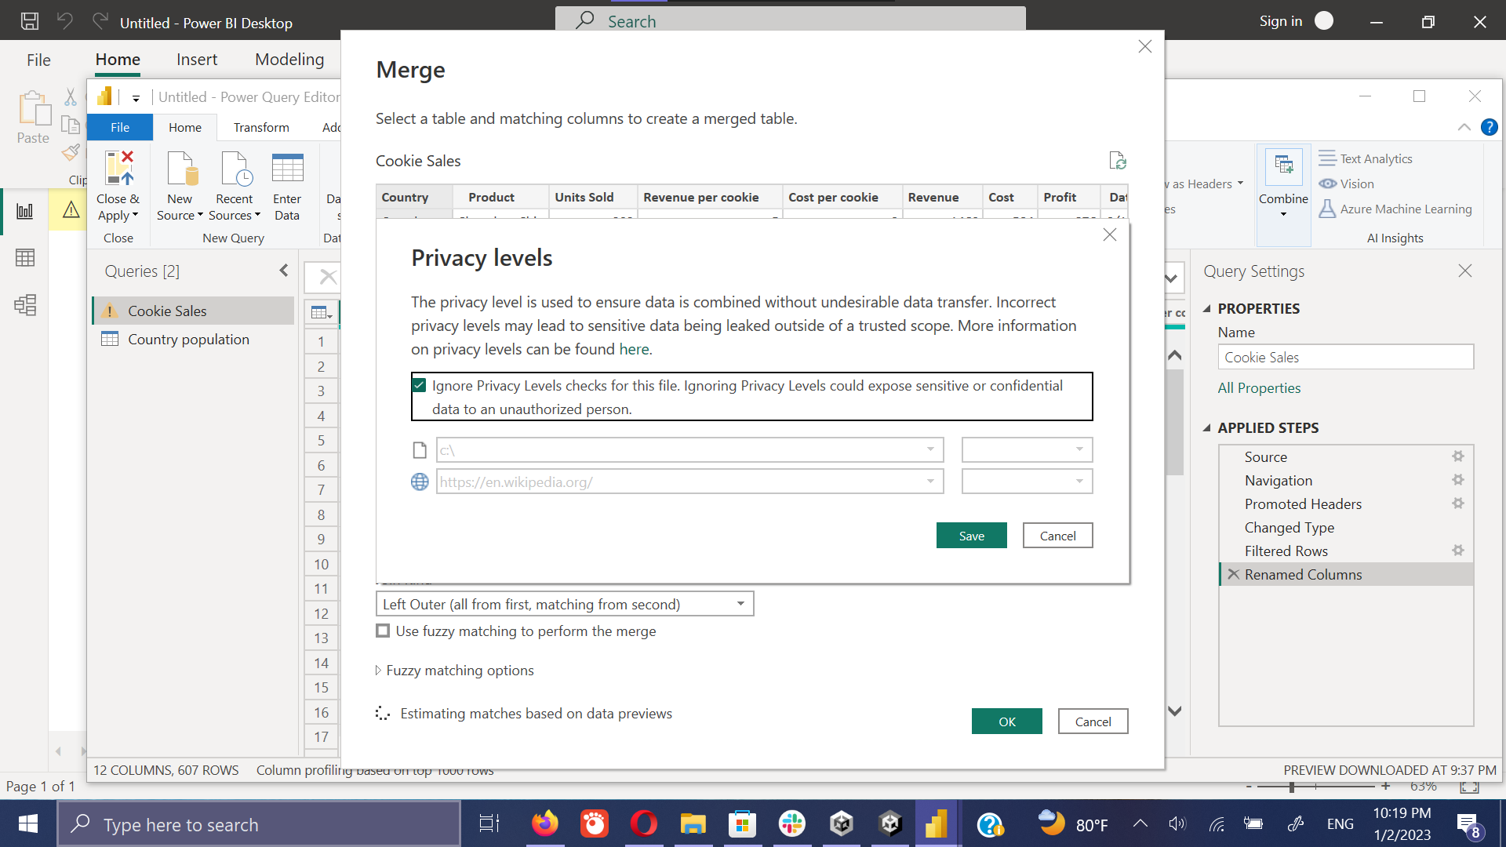

Then it merges the two data set and displays as below. Then it needs to select the **population** from the filter option to displays the merge table correctly.

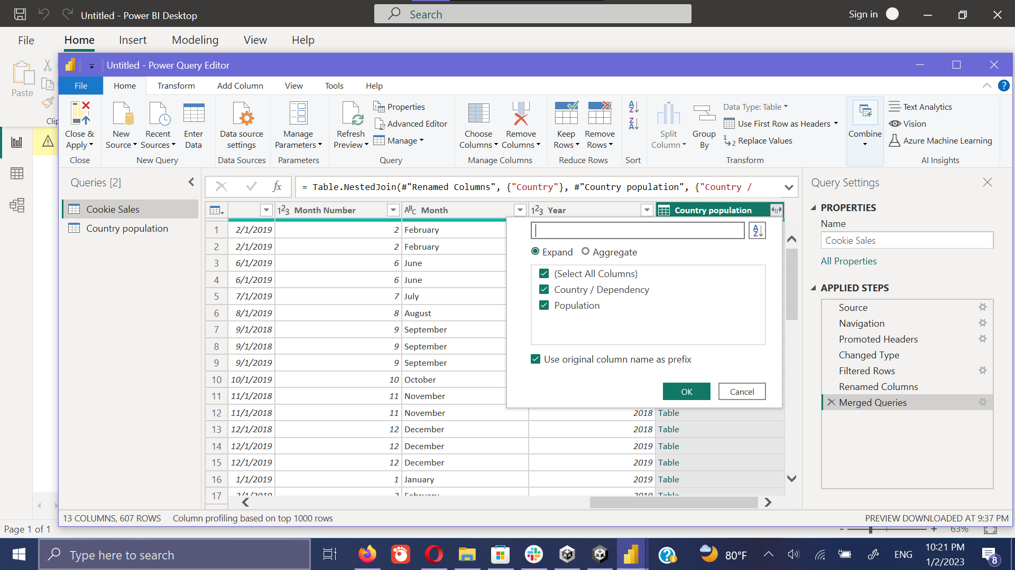

Final merged dataset displays as bellows. Then it needs to click on the **Close & Apply** option in the menu bar to apply load this date set from power BI query editor to the dashboard.

Click on the **close & apply**

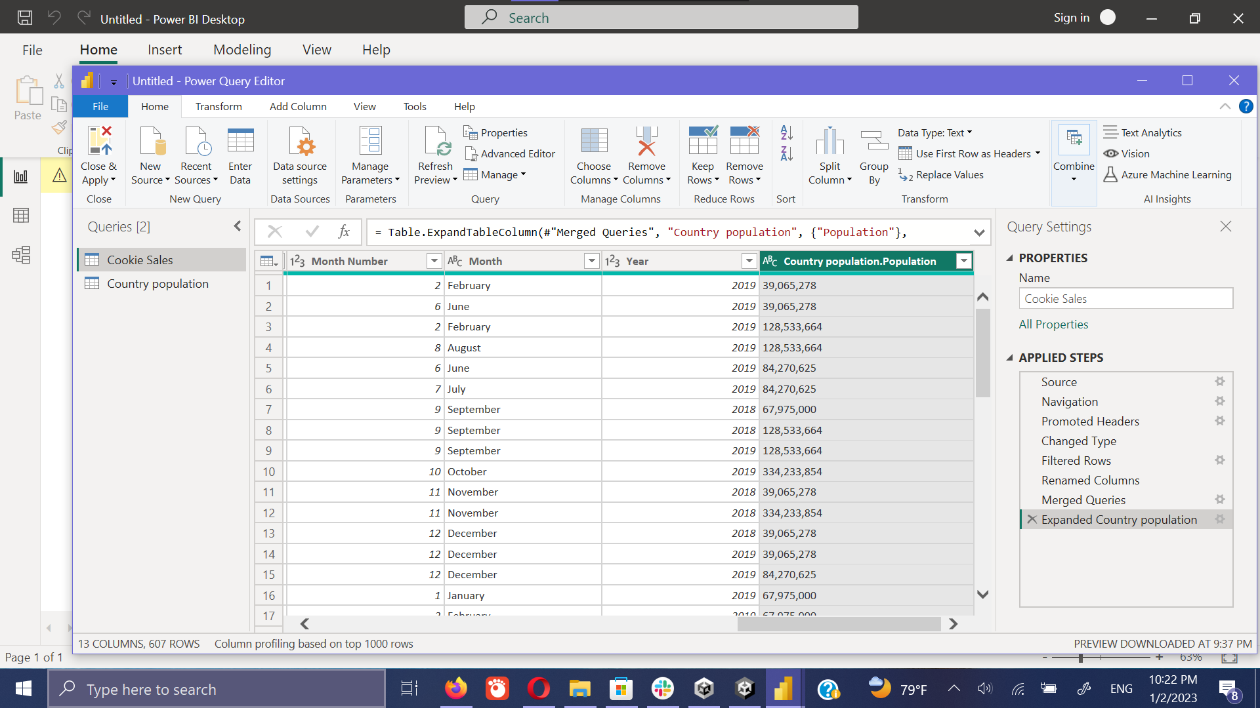

**Loading window** (This shows the success status of loading data set to the dashboard.)

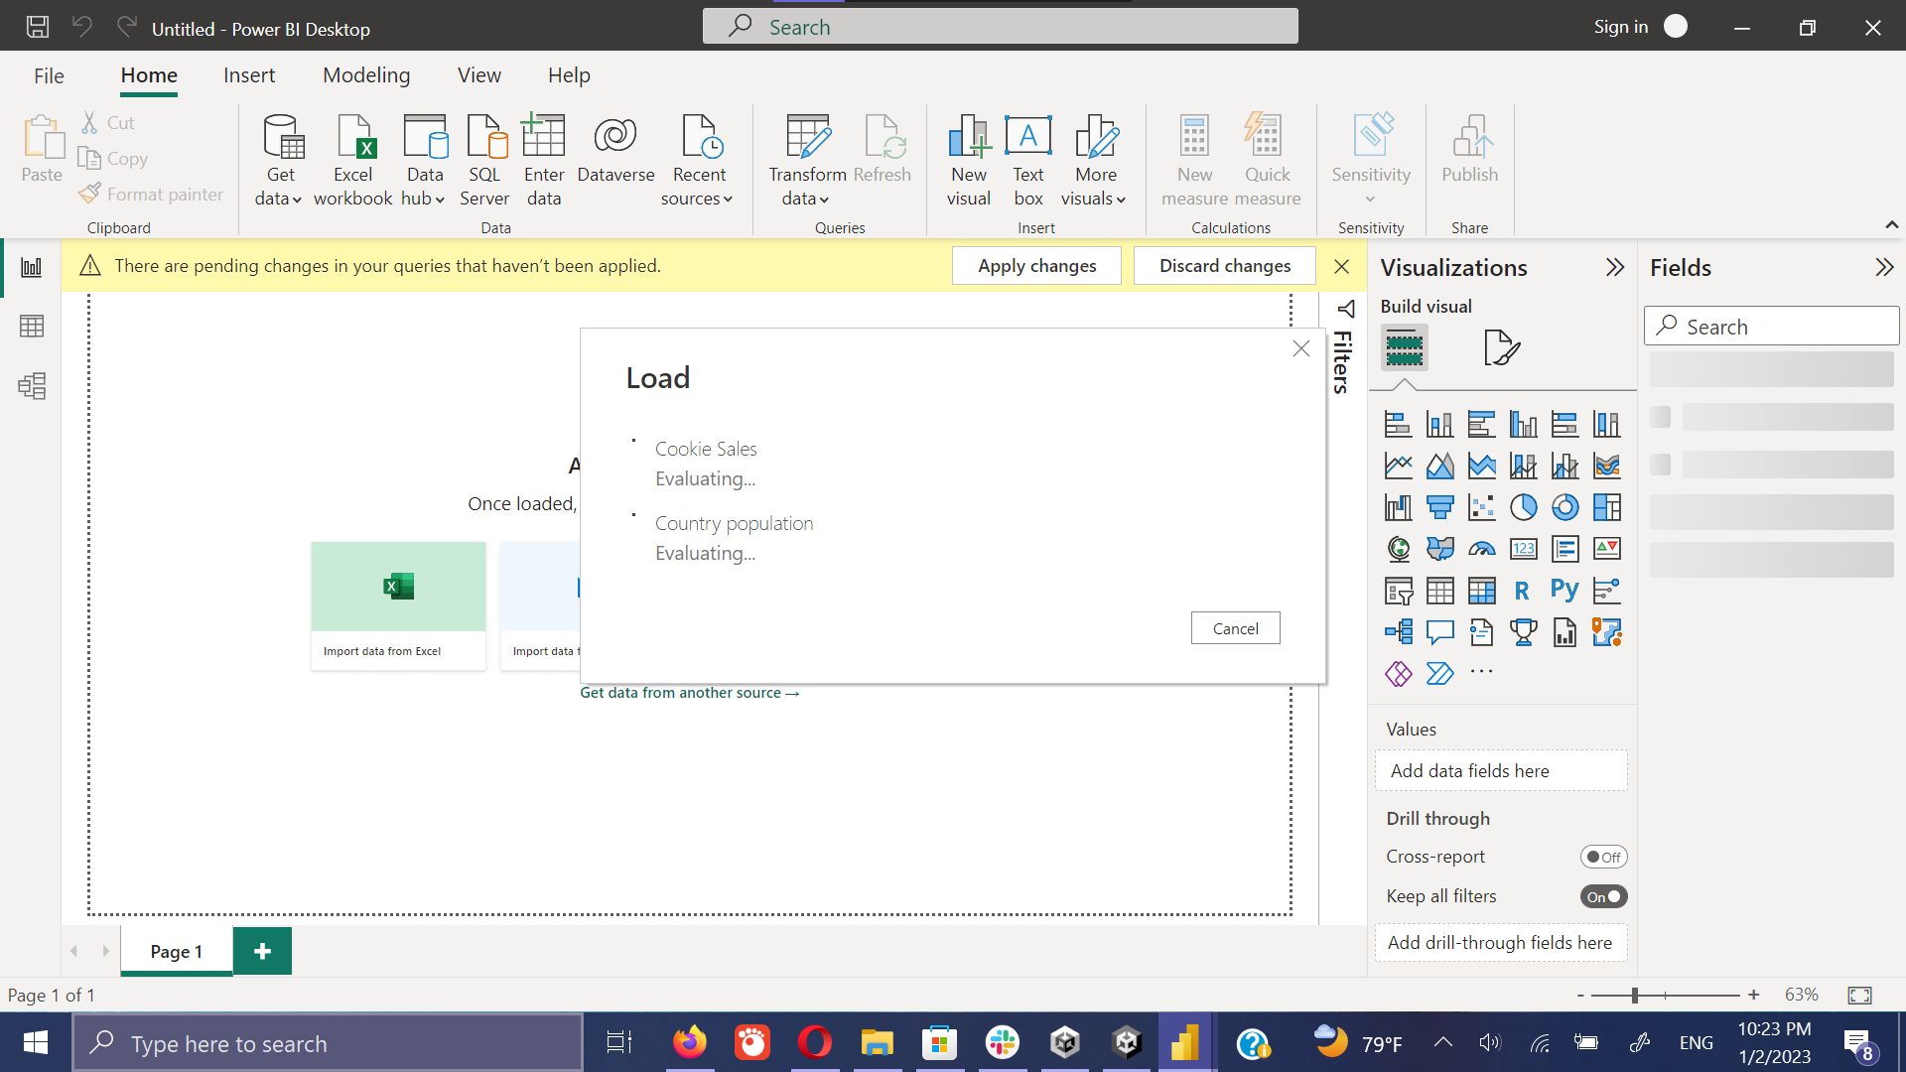

Below shows a way to check whether the set connection have activated on the data sets. To get the view it needs to click on the **Model** tab in the left-hand side.

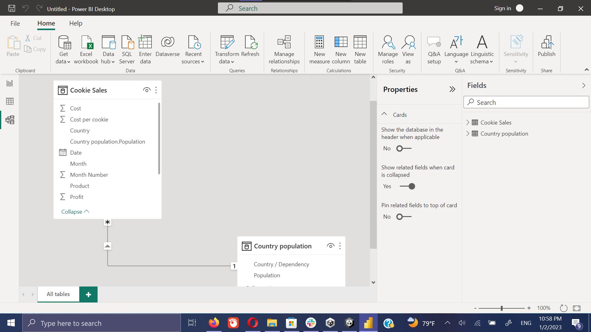

Now all set to go. We have successfully merged and loaded the required data sets.

Create dashboard on required analysis.

1. Get profit by day

Click on the **Profit** on the fields section then on the **Date** on the fields. Then it will generate below screen.

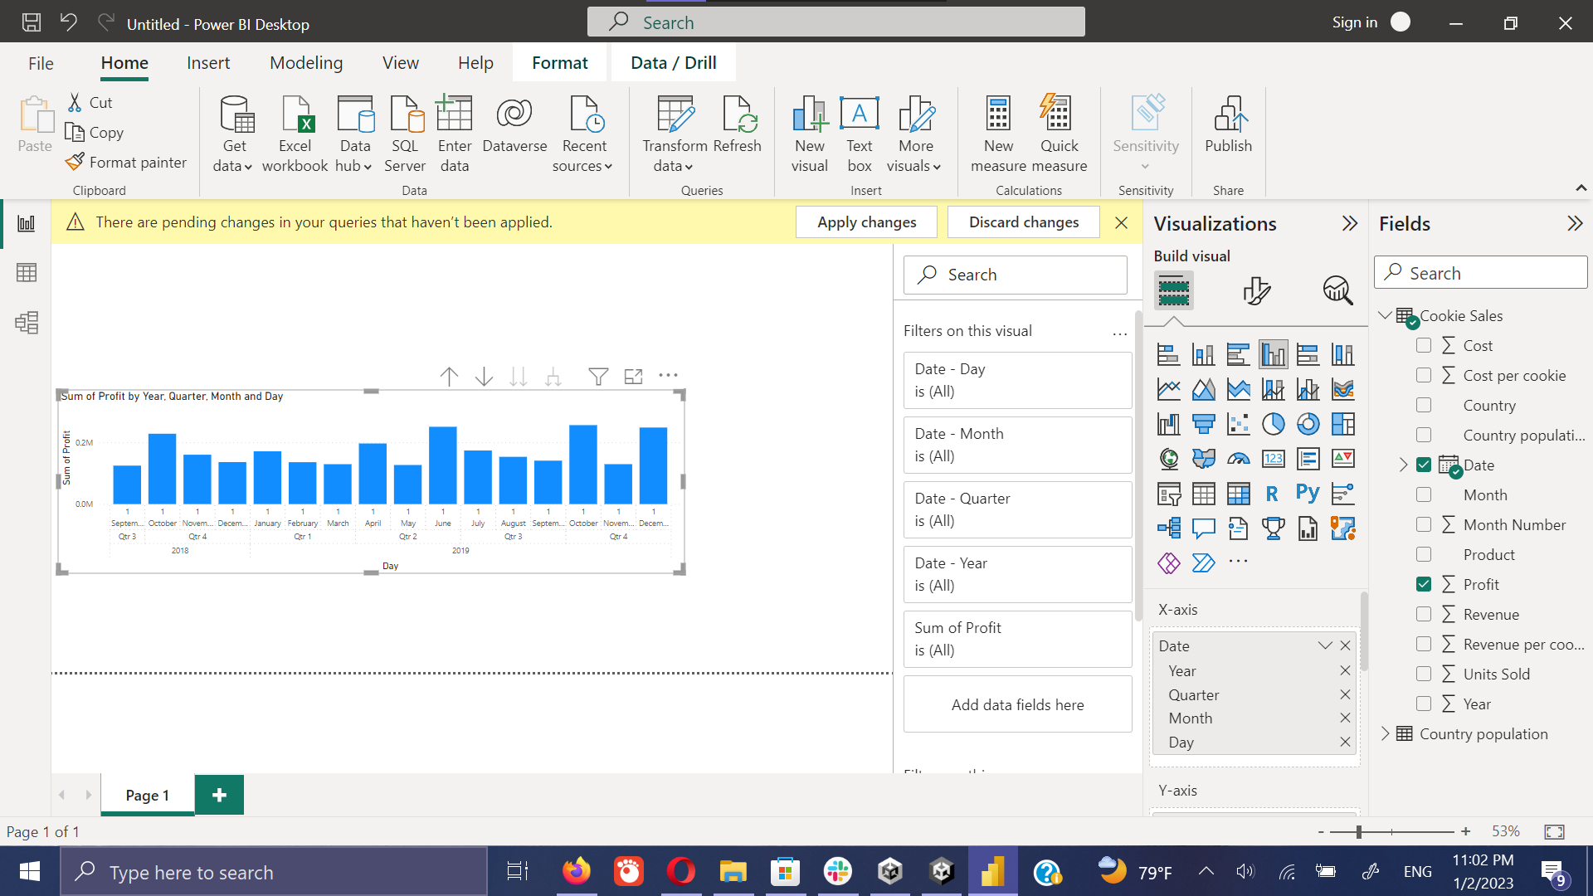

To create the view into to the date and profit format it can select the **Date** from the **X-axis.**

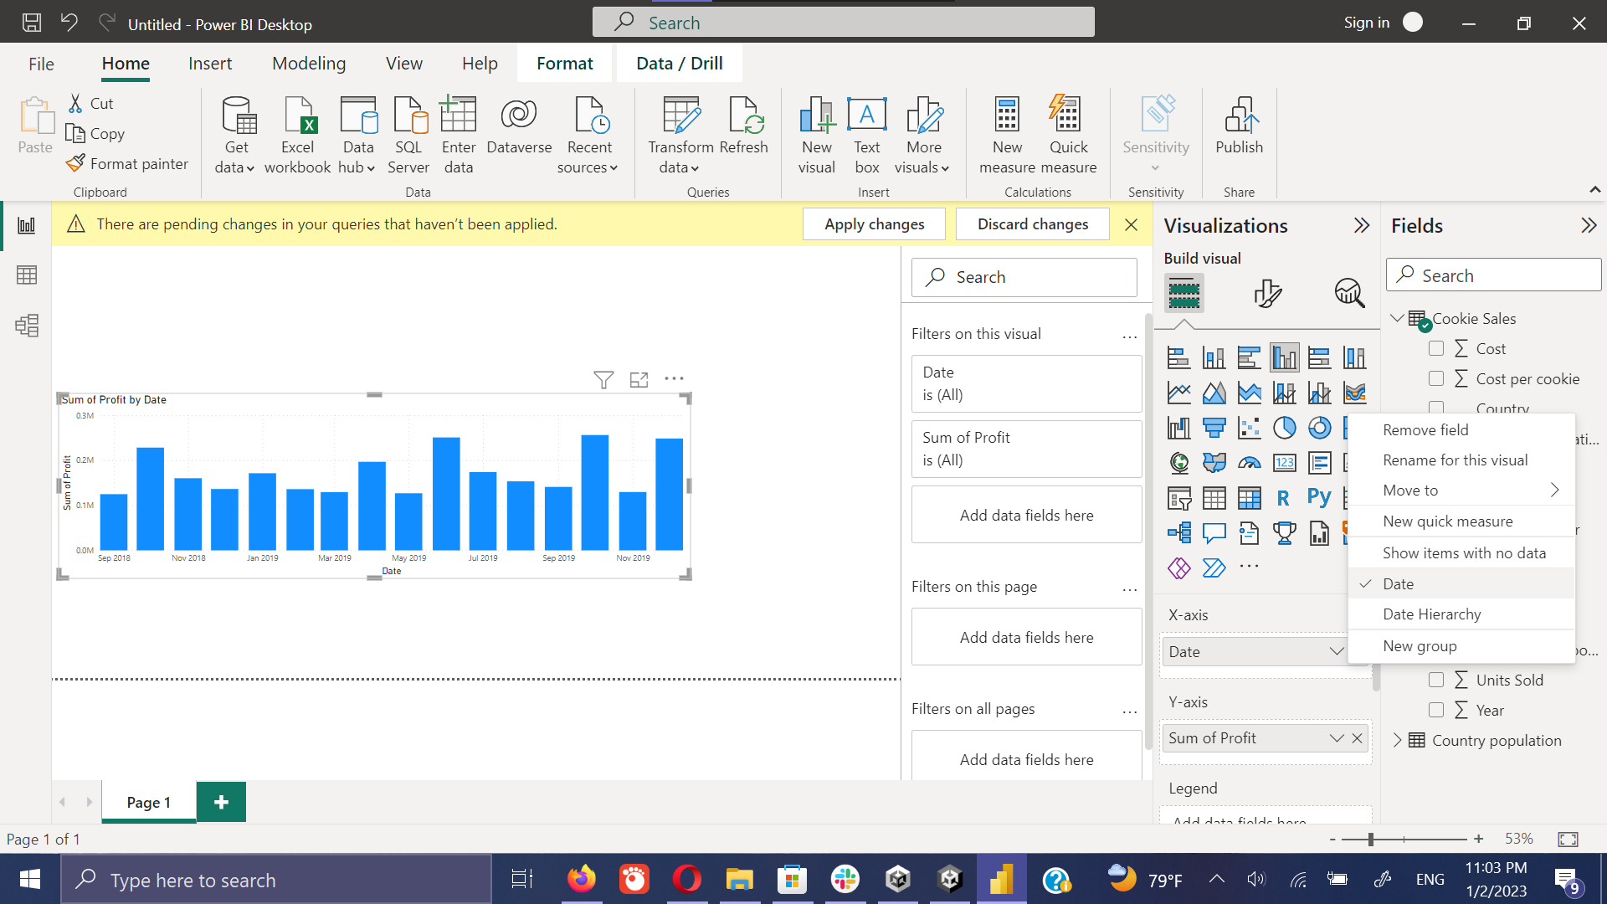

1. Change the bar chart to line chart.

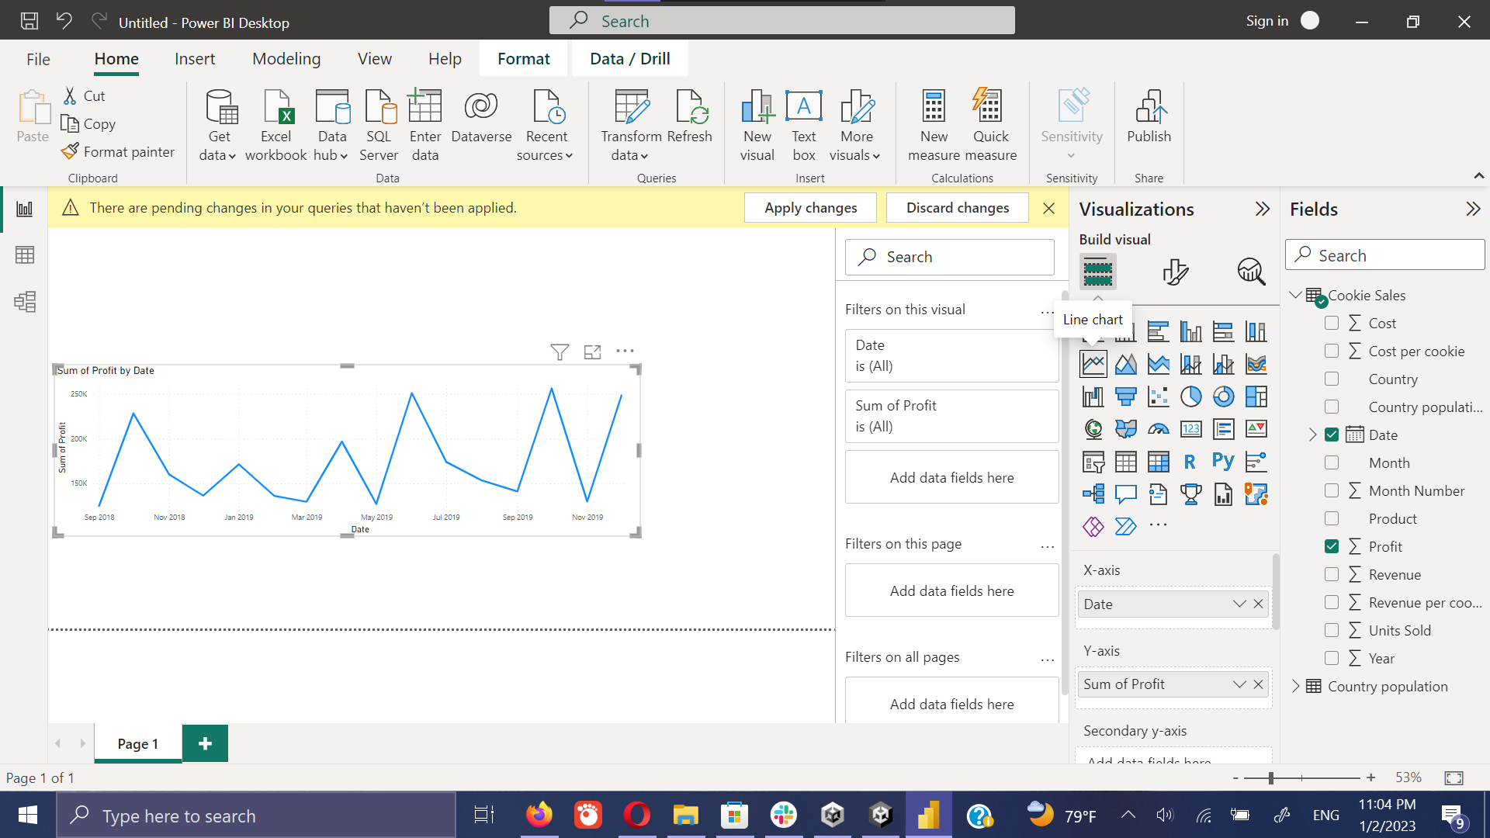

1. Profit by the Geography

Select the **country** and **profit** from the fields section then click on the **map** icon on the **visualization**.

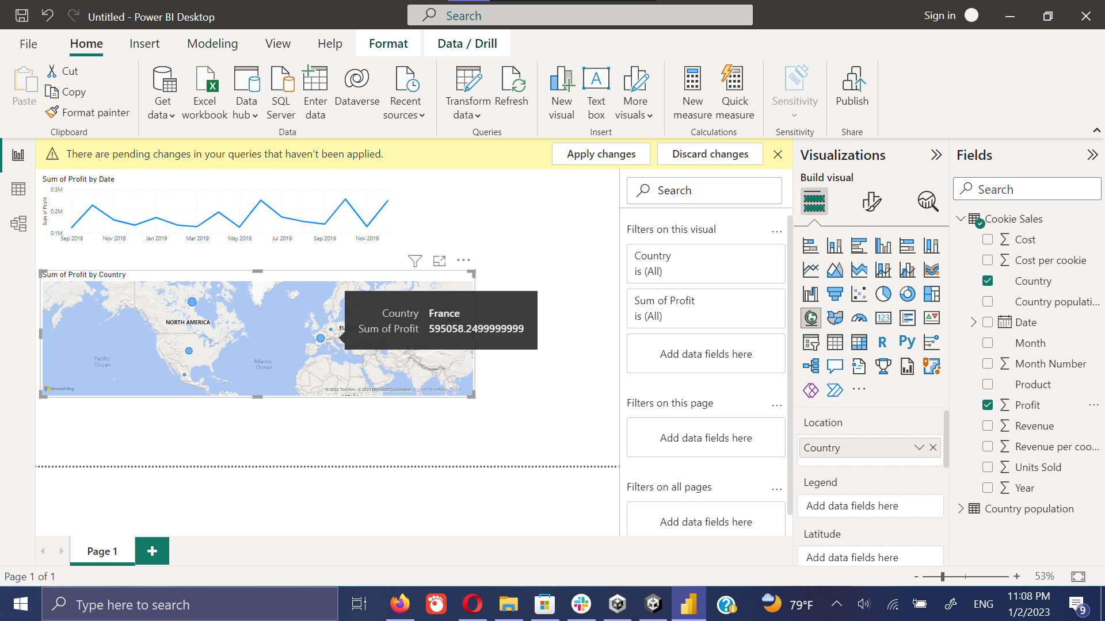

1. Change the map into Tree map

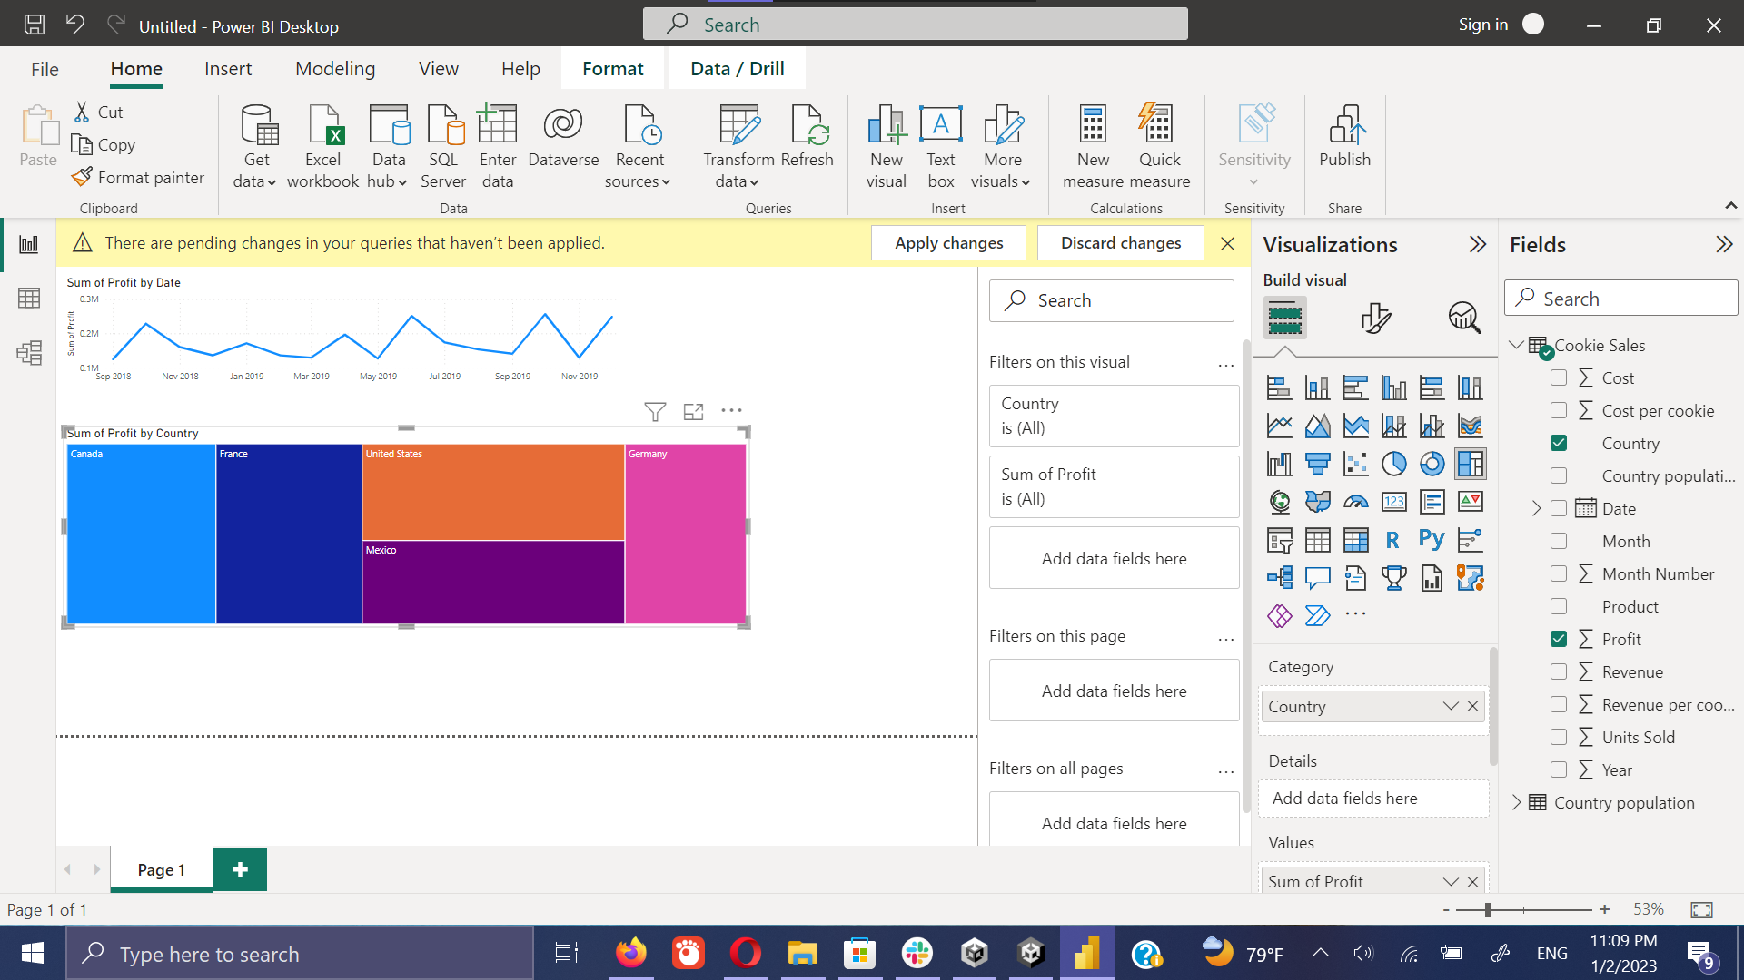

1. Create table on **population** by the **country** and the **unit sold**

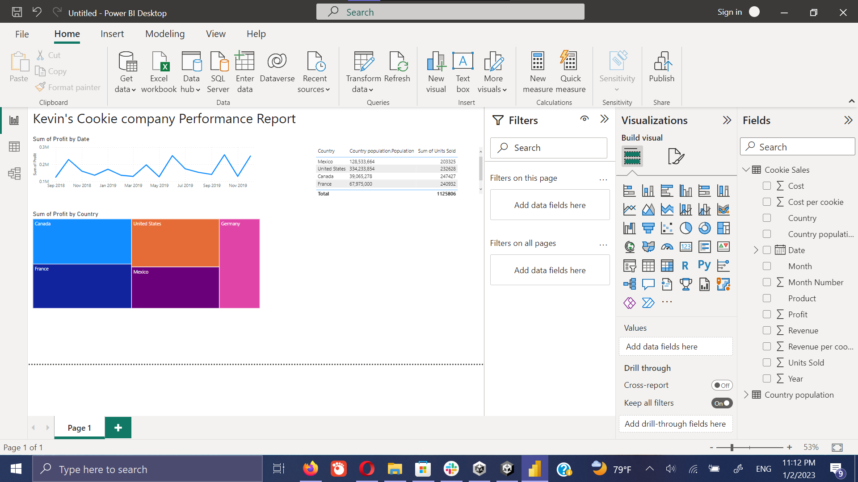

1. Create profit by product wise

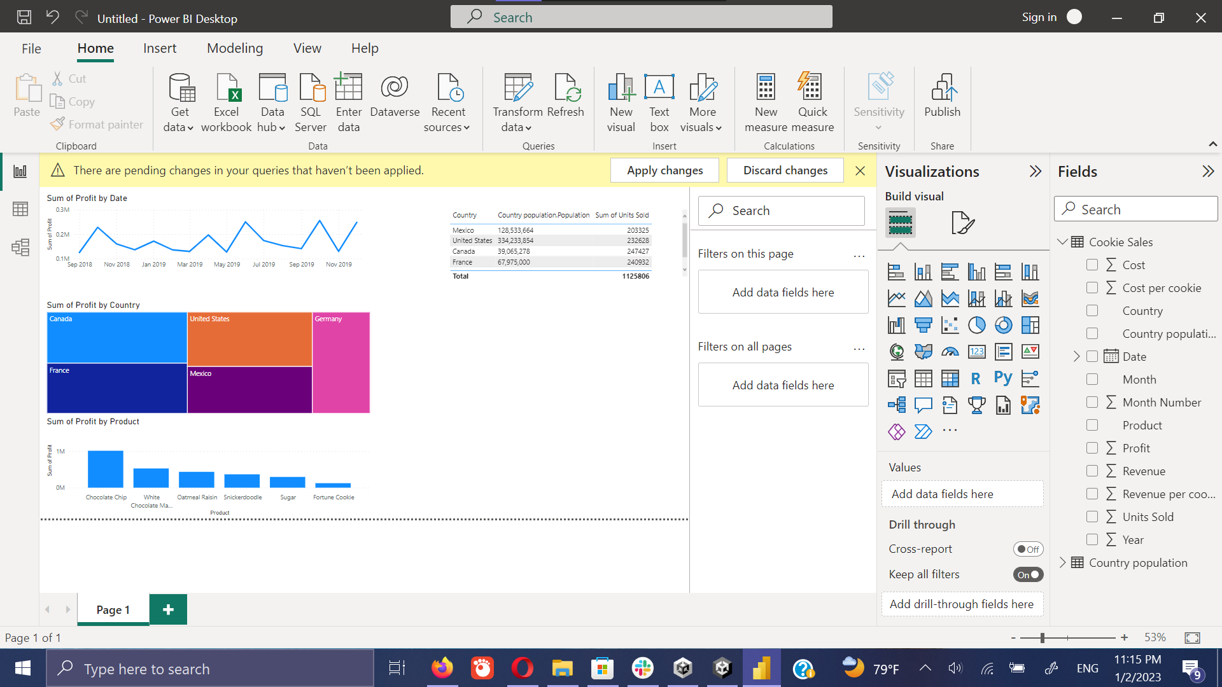

1. Adding slicer

Slicer can use to filter the plots using the required data. Here It is going to filter the plots using the country. It can be done easily by selecting the country on the slicer.

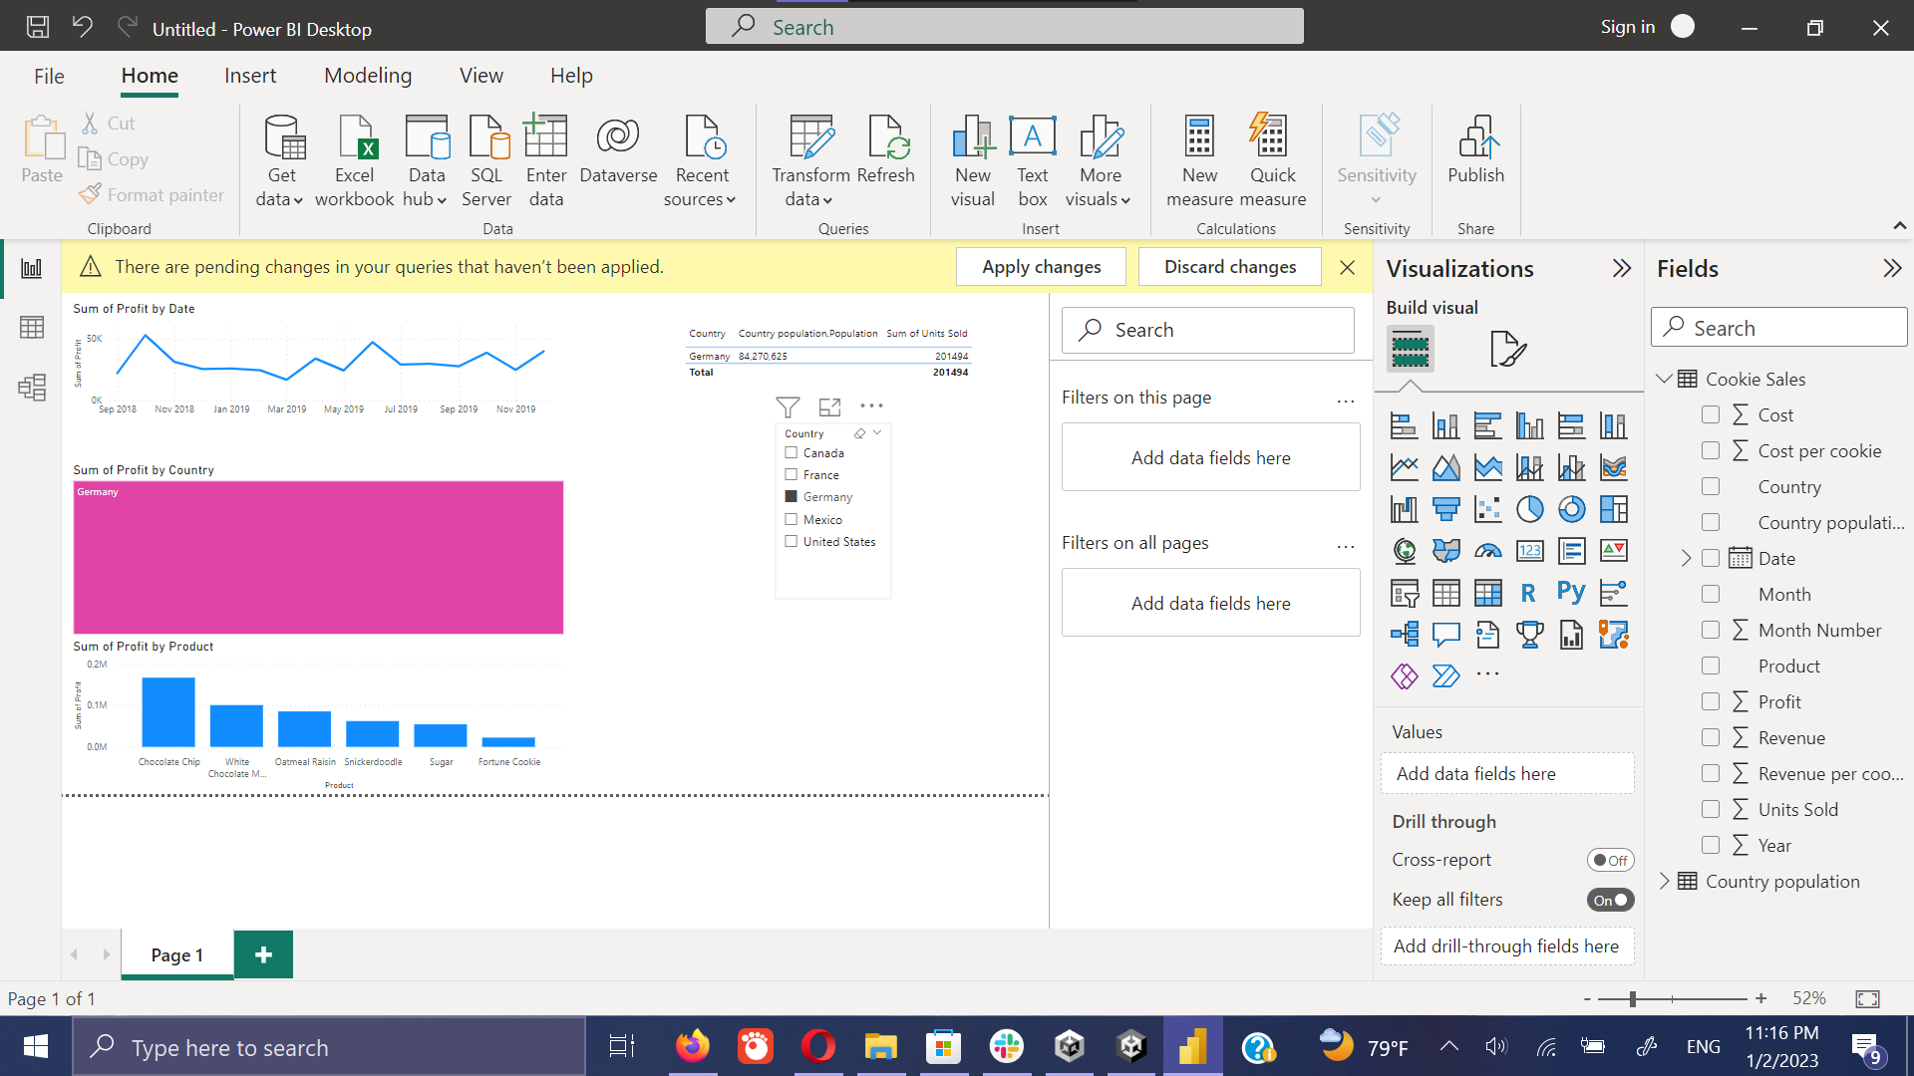

1. Change the look and feel.

It can change the look and feel, it can easily be done by the navigating to the **view** option in the menu bar.

